DNA / Protein Sequence Analysis Using BLAST
Name: Eman Majeed
Internship ID: CA/DF1/23153
Domain: Bioinformatics
Task: Task 1 – DNA / Protein Sequence Analysis
Tool Used: NCBI BLASTp
- Introduction
Bioinformatics serves as a scientific discipline that merges biology with computer science and information technology to study biological data. The primary purpose of bioinformatics protein sequence analysis enables scientists to study protein function and structure together with protein evolutionary connections. The National Center for Biotechnology Information (NCBI) created the Basic Local Alignment Search Tool (BLAST) which serves as a popular bioinformatics tool. The tool enables users to compare biological sequences with extensive databases in order to find matching or similar sequences. The research utilized BLASTp to assess a protein sequence and discover corresponding proteins throughout various species.

- Objective The objectives of this task are: To retrieve a protein sequence from the NCBI database To perform BLASTp analysis To identify homologous protein sequences To analyze similarity parameters such as percent identity, query coverage, E-value, and alignment score

3. Materials and Tools Used
NCBI Protein Database
NCBI BLAST (BLASTp)
Web Browser MS Word / Google Docs

- Methodology

  - Protein Sequence Selection
The protein hemoglobin subunit alpha [Homo sapiens] was selected for analysis. Hemoglobin serves as a crucial protein that transports oxygen throughout the human body while its molecular structure remains unchanged across various species. The reference sequence used was: NCBI Reference Sequence: NP_000508.1 Sequence Length: 142 amino acids. 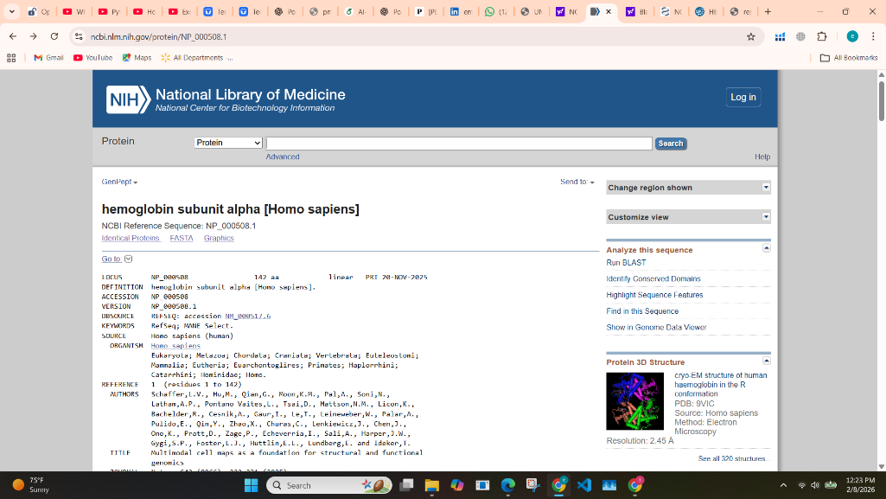

  - FASTA Sequence Retrieval

The NCBI Protein database provided the protein sequence which researchers retrieved in FASTA format. The FASTA format begins with a header line which is followed by an amino acid sequence that BLAST analysis can utilize.

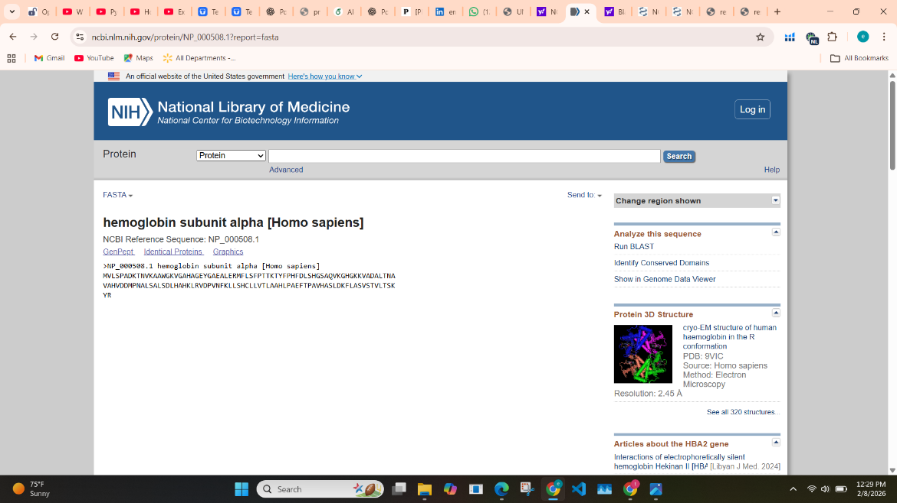

  - BLASTp Analysis

The researchers used BLASTp to examine the protein sequence against the NCBI non-redundant protein database with default parameters. The researchers pasted the FASTA sequence into the BLASTp query box to execute their analysis.
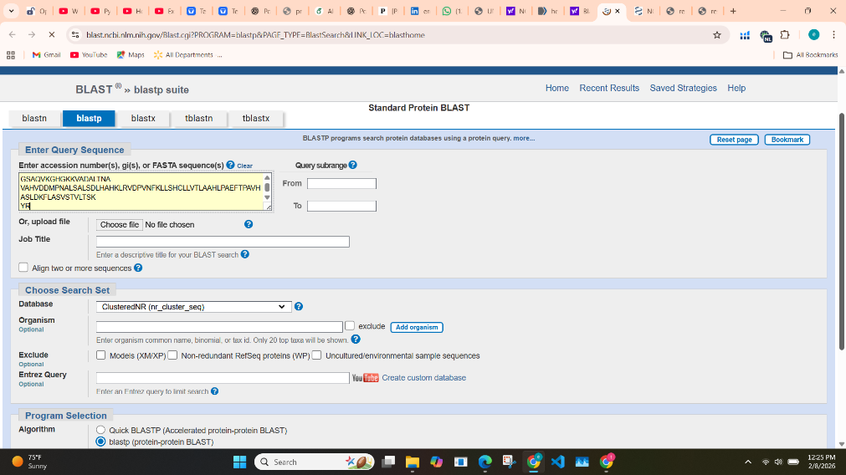

- Results

The BLASTp analysis produced multiple significant matches which displayed high similarity to hemoglobin proteins found in various organisms.

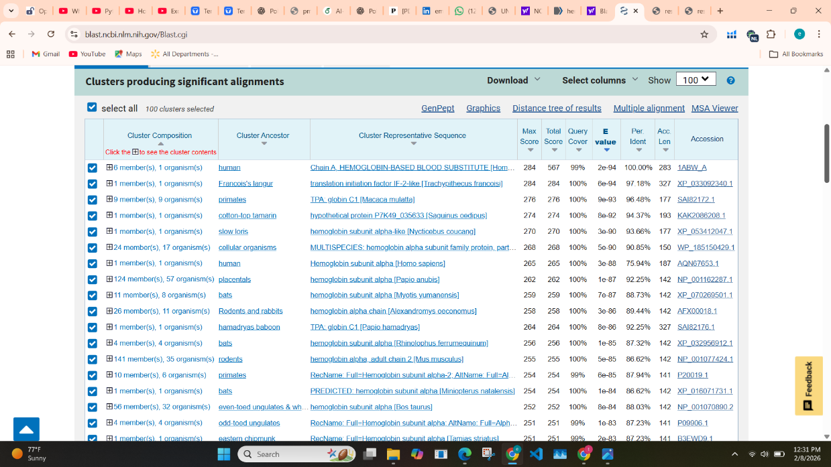

  - BLAST Result Parameters Percent Identity:

Measures exact amino acid matches Query Coverage: Indicates how much of the query sequence is aligned E-value: Represents statistical significance (lower is better) Alignment Score: Reflects alignment quality.
Protein Name | Organism | Percent Identity | Query Coverage | E-value
Hemoglobin subunit alpha | Homo sapiens | 100% | 99% | 2e-94
Hemoglobin subunit alpha-like | Trachypithecus francoisi | 97.18% | 100% | 6e-94
Globin C1 | Macaca mulatta | 96.48% | 100% | 9e-93
Hypothetical protein | Saguinus oedipus | 94.37% | 100% | 8e-92
Hemoglobin subunit alpha-like | Nycticebus coucang | 93.66% | 100% | 3e-90

Alignment Analysis
The alignment results show that amino acid sequences between different species maintain strong conservation. The E-values show very low values which prove the similarities between the two entities exist as statistically significant results that don't happen by random chance. The conserved regions of hemoglobin show which parts of the protein perform vital biological functions.

Discussion
The BLASTp results demonstrate that hemoglobin subunit alpha shows high conservation across multiple species with particular emphasis on primates and mammals. The high percent identity combined with complete query coverage indicates strong evolutionary connections between the two species. The conserved regions of the protein function as essential components for oxygen binding and transport, which demonstrates the vital role of hemoglobin in all living organisms.

Conclusion
The research work used BLASTp because it provides effective protein sequence analysis tools. The hemoglobin subunit alpha protein showed high similarity with homologous proteins from multiple species. The research demonstrates how bioinformatics tools such as BLAST enable scientists to study protein evolution through their conserved functions.

